

**School of Computer Science and Statistics**

**Individual Assessment Submission Form**

|  |  |
| --- | --- |
| **Course Title** | TEP |
| **Module Title** | TEP 00062 |
| **Lecturer(s)** | Prof Dave Lewis, Prof Vincent Wade |
| **Assessment Title** | Individual Assignment on Ethical Digital Engagement |
| **Date Submitted** | March 30, 2024 |
| **Word Count** | 3154 |
| **Student Number** | 21365006 |
| **Student Name** | Emma Mulroy |

**Assignment Submission Declaration:**

I have read and understand the plagiarism provisions in the General Regulations of the University Calendar for the current year, found at: <http://www.tcd.ie/calendar>

I have also completed the Online Tutorial on avoiding plagiarism ‘Ready, Steady, Write’, located at <http://tcd-ie.libguides.com/plagiarism/ready-steady-write>

I declare that this assignment, together with any supporting artefact is offered for assessment as our original and unaided work, except in so far as any advice and/or assistance from any other named person in preparing it and any reference material used are duly and appropriately acknowledged.

Any use of Chatbots/Generative AI tools in researching the materials research for this report is fully described at the end of the report. I confirm that no text produced by such tools has been directly used in the report.

Signed Emma Mulroy Date 30 March 2024

Description of use of Chatbots/Generative AI tools:

ChatGPT was used to explain concepts that were difficult to me such as the ethical risks of fair operating procedures. The information provided was not directly used but just to aid in my understanding before I carried out my research.

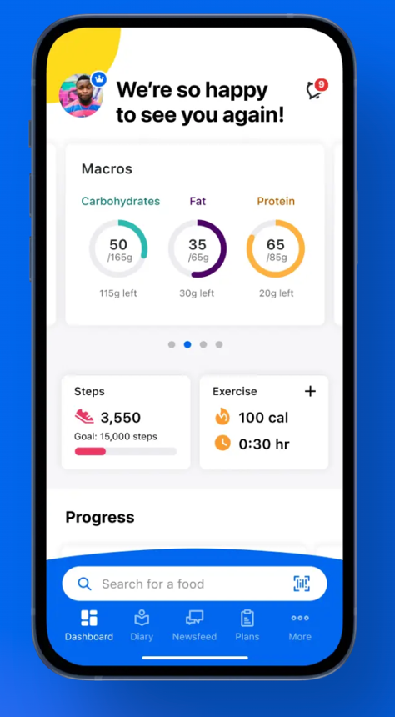**MyFitnessPal**

**Description**

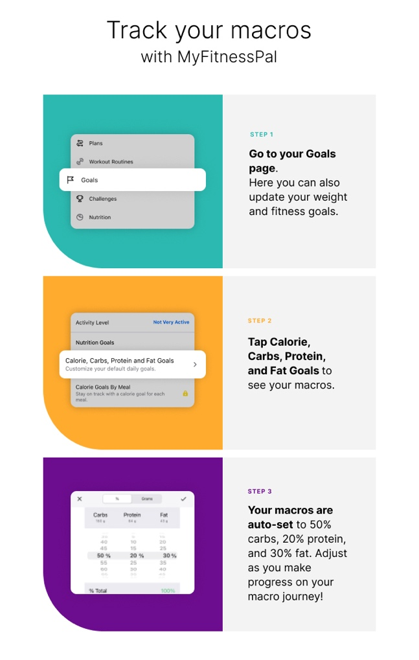MyFitnessPal is one of the most widely used health and fitness applications that helps millions of users worldwide optimize their health, whether it be weightloss, nutrition goals, fitness goals or tracking sleep. Users can also gain support from an online community. MyFitnessPal was founded in 2005 by Mike and Albert Lee but was acquired by Under Armour in 2015. MyFitnessPal is a platform that users can utilize to track their calories, nutrition, exercise, and sleep. Not only does MyFitnessPal allow the user to track calories, but it can also be used to track macros, vitamins, and other micro - vitamins. Everything that is logged into MyFitnessPal allows support of the user’s individual goals whether it be a high protein diet, low carbohydrate, or fat, etc.

Figure : MyFitnessPal home screen

Figure : Macronutrient tracking on MyFitnessPal

MyFitnessPal has a huge database of foods, with almost 14 million foods on the

app. The app is available for both Android and iOS devices. The user can scan a barcode of a food product or search for it on the app, they will then be able to see all the nutritional information and log it into their ‘diary’. AI has revolutionised the logging of food products into MyFitnessPal. MyFitnessPal uses AI to learn about the foods you eat, and what recipes you cook this saves time and makes tracking calories easier.

The standard subscription will only allow users to track calories, weight, steps, and exercise. A premium subscription offers additional features for users aiming to unlock more advanced functionalities such as custom macronutrient tracking, heart health information, as well as zero ads. Research shows that members are 65% more likely to reach their goals with a premium subscription.

Macronutrients are often abbreviated to macros, and the three most important macronutrients are carbohydrates, proteins, and fats. Depending on your age, sex, and activity level your body will require certain amounts of these macros. Depending on the goal of the user whether it be to weight loss, muscle gain, improvement of cardiovascular fitness or general healthy eating habits the app will aid users in goal creation and track progress over time, MyFitnessPal uses an AI Macro Calculator to gain valuable insights into the user’s macronutrient goals, depending on their own goal. For example, a person wishing to follow a ketogenic diet will have 70%-80% of their calorie intake for the day coming from fat sources, 10%-20% of their protein intake coming from proteins and 5%-10% coming from carbohydrates. Users can set a daily calorie goal, as well as specific calorie goals for each meal and snack, this will help the user to stay on track of their goal. Throughout the day there will be notifications to log food.

In 2021, MyFitnessPal introduced a new AI-powered scanning feature that plays a role in identifying and tracking the ingredients in the food items that the user logs into the app. The company partnered with Passio, to create the MealScan feature, which is powered by “state of the art Nutrition AI SDK” The app uses image recognition to identify foods and portion sizes to log your daily calorie and nutrient intake accurately. To successfully diet nutrition tracking is paramount, traditional methods of looking at labels were tedious, and users would lose motivation after a while. AI can also be used to provide tailored nutritional recommendations for the user to reach their desired goal. The use of AI has helped users to adopt a healthier lifestyle. Tracking foods can be a monotonous process and users are likely to lose motivation after a week or two. This new feature helps users avoid having to search for food and ingredients within the database so tracking foods has never been more convenient.

Figure 3: Meal Scan feature on MyFitnessPal

As well as the meal scanning feature on MyFitnessPal, there is also an AI-driven community feature – where users can interact and compete with each other whether it is exercise or weight logging. The community feature uses AI to ‘match’ people with similar health and fitness goals. The MyFitnessPal community helps users to support each other along their fitness and health journey. Users can ask questions and get help from other members on anything health and weight loss related. Users can also post and share tips, and nutritional advice and discuss ways of eating. As well as this, users can share their favourite recipes and share fitness tips and exercise suggestions.

MyFitnessPal has the ability to synchronize with wearable technology such as the Apple Watch and other tracking apps to allow information to be uploaded from multiple sources. This is useful because information on weight, health, calorie intake and activity are all kept in one place.

**Identification of stakeholder roles involved in the application and its governance.**

Under Armour acquired MyFitnessPal in 2015 but sold it to investment firm Francisco Partners in 2020. The main stakeholders are the users, data scientists, product managers, privacy experts, engineers, and healthcare professionals.

**Users**

Premium subscription users are important to the upkeep of MyFitnessPal. A premium subscription has additional features to increase the app’s customizability and flexibility. A premium subscription costs €20 per month or €80 per year. Users interact with the app to track their diet, nutrition and activity. As well as this users are interacting with each other using the community feature. Features provided by a premium subscription include food analysis ( to see which foods are good and bad for you), quick add nutrients (adds to convenience), priority customer support, ad-free, Meal Scan, workout routines and a barcode scanner. These features help to keep the user engaged and drive subscriptions when satisfied users leave good reviews. Users play an important role in the governance of MyFitnessPal by spreading awareness and the benefits of the app by word or mouth and on other social media platforms. There is many benefits to driving premium subscriptions to MyFitnessPal including; increased revenue, job creation, app improvements, as well as improved health of society.

Figure 4: good reviews driving user engagement on MyFitnessPal

**Data Scientists:**

The data scientist team at MyFitnessPal prioritise artificial intelligence and machine learning in their product portfolio while maintaining a rigorous scientific engine. The team want to create a personalized experience for the user to achieve success on their health and fitness journey. The data scientists at MyFitnessPal work closely with product managers and business stakeholders to formulate and build machine learning products, they help to track progress so goals can be reached. They play an important role in the governance of the app as they work on innovative application improvements to drive user engagement. Data Scientists have succeeded in their role to include Artificial Intelligence into MyFitnessPal which no doubt has driven user engagement because the app has become more convenient for health and fitness gurus to use.

**Product Managers:**

Product managers at MyFitnessPal play an important role in the development and success of the app, they take ownership of projects and work alongside the company’s other stakeholders to deliver the main goals of MyFitnessPal. Product managers have a wide variety of roles within the company, from brainstorming new services and features to working with engineering and design to deliver projects. Product managers would also be involved in data collection to get positive and negative feedback on MyFitnessPal. When a feature such as Meal Scan is in the pipeline, product managers will manage the entire lifecycle by working closely with engineering, design, marketing, and data scientists to ensure that it is high quality and delivered on time. By analysing app performance, product managers can create a plan of action on how they want to proceed to drive user engagement.

**Privacy Experts**

Involved in the upkeep of GDPR and data privacy standards. The user does share a large amount of personal information with MyFitnessPal; therefore the user needs to have confidence in the company to keep all personal information confidential. They are involved in the write-up of privacy policies, in line with country-specific regulations. They play an important role in the governance of MyFitnessPal as they help to give the user peace of mind when it come to their personal data being secure.

**Engineers**

Engineers are involved in the running of the backend systems that drive MyFitnessPal. They are involved in the maintenance and operational activities of MyFitnessPal. Their technical expertise comes into play whenever there is an issue with the running of the app. The app must run well to drive user engagement. Engineers would work with quality assurance to carry out tests on new features to ensure that there is no issues before it reaches the customer.

**Healthcare Professionals**

Healthcare professionals often recommend apps such as MyFitnessPal to their clients to monitor their health and activity levels. Healthline is a website that provides medical information and health advice, they recommended the use of MyFitnessPal in the management of Type 2 diabetes. MyFitnessPal gives a nutrient breakdown of certain types of food and knowing what types of food would cause a fluctuation in blood sugar can cause a diabetic to make healthier food choices. Healthcare professionals play an important role in the governing if the app by driving user engagement, and by providing professional advice as people are more likely to listen to a doctor.

**Regulatory Agencies**

There are third parties associated with MyFitnessPal including law enforcement, government, and regulatory bodies. MyFitnessPal must comply with GDPR standards for the protection of personal data. Regulatory agencies provide external governance over MyFitnessPal to ensure the user is protected.

**Identification of Ethical Risks**

**Human Rights:**

By agreeing to the privacy policy that MyFitnessPal set out, “you consent to the transfer and processing of the information in the United States”. For residents of the European Union, MyFitnessPal “process your Personal Data and provides other information required by the GDPR”. MyFitnessPal uses this data for advertising and marketing purposes as well as providing health and fitness services to the user. When you sign up to MyFitnessPal, some of your personal data is collected, this includes name, photo, username and password, email address, date of birth, gender, payment information and general location data. MyFitnessPal will store data on dietary habits, weight, fitness levels, heart health and Body Mass Index (BMI). This data is used to create personalized recommendations such as meal plans and workout plans. When you connect a technology such as a Fitbit or an Apple Watch, MyFitnessPal will use the data stored on these technologies. If there is a data breach within MyFitnessPal, this personal data could be compromised and misused. This would affect the users and subscribers to MyFitnessPal, it would have a severe impact on the users as it is very personal information. On March 25, 2018, Under Armour alerted customers that a data breach had occurred, which affected 150 million accounts. Cybersecurity experts secured the app and continuously monitor the app for any unusual activity so the risk of another breach would be presumed unlikely but not impossible. The information stored in MyFitnessPal can be used for identity theft or information could be sold on the dark web. A major challenge for maintaining ethical integrity is the lack of documentation in regards data privacy and confidentiality

**Labour Practices**

Based on reviews on glassdoor.co.uk there is a high rating for labour practices for the MyFitnessPal employees. There are high ratings for culture and values, diversity and inclusion, work/life balance, compensation and benefits and career opportunities. MyFitnessPal is dedicated to advancing, cultivating and preserving a culture of diversity, equity, inclusion, and belonging. Employees would be the main stakeholders that would be affected by labour practices. If there were to be a change in labour practices the level of severity of the impact would depend on whether it was a positive or negative change in labour practices. I think the likelihood is low-medium. This can be justified by the positive reviews of employees safer, however a change in management or the way the company is run could cause an impact on labour practices.

**The environment**

The personal data that is retained by MyFitnessPal can be printed on paper and stored in files, which is destroyed when it no longer serves its purpose, for example, when an account is deleted. Personal data stored on paper can be shredded, burned or incinerated. Data stored in electronic form is deleted using technology to prevent its recovery. The destruction of personal data stored on paper would have a harmful impact on the environment. The burning of these files would contribute to climate change. However, as would be expected majority of information is stored in data centres. Huge amounts of energy is needed to power data centres, this would lead to a rise in carbon emissions. The main stakeholder that would be affected by this is the public. There is quite a high impact as a society we are having concerning issues regarding climate change. I think the likelihood of this being an issue is medium. There is an impact and there is continued technology use and commercial innovation to mitigate the impact of energy use in data centres. There is a scope that MyFitnessPal will turn to renewable sources of energy to power data centres and reduce their carbon footprint.

**Fair operating procedures**

To comply with fair operating procedures, there must be extensive data protection policies in place to prevent a data breach. MyFitnessPal also has algorithms to calculate the daily number of calories you should be eating to be in a calorie deficit or surplus depending on the user’s goals. There is a risk that the algorithm that MyFitnessPal use to calculate the daily number of calories consumed may be inaccurate for the user’s desired goal. For example a user who has more muscle will burn more calories in a day in comparison to a person with more body fat. Therefore, the basal metabolic rate (BMR), the amount of calories that are burned as your body performs life-sustaining functions, for those with more muscle have a BMR. As MyFitnessPal works primarily off age, weight, and height it does not consider the amount of muscle the user may have. Therefore, an ethical risk could be an inaccurate calculation which will lead to a misleading daily calorie intake for the user. This could have a medium impact on the user’s result if they experienced unexpected weight loss or gain. The likelihood of this happening Is low to medium. This can be justified by the fact that people with muscle generally are aware of nutrition goals and basal metabolic rate as it would have taken a calorie surplus as well as food that is high in protein to build muscle initially. People starting out on a weight loss journey may not have much muscle so therefore the general calculation will be accurate to maintain a calorie deficit.

**Consumer issues**

The main consumer issue that would arise with MyFitnessPal is a data breach. A breach of personal data could lead to hackers using the information for identity theft. This would have a severe impact on the user.

**Community involvement and development**

While having a support system to help you reach health and fitness goals is an important part of MyFitnessPal, there are some ethical considerations. The ethical considerations mainly revolve around the sharing of personal data. Users of the community feature on MyFitnessPal have to be careful in what they choose to share with the public. Another issue is the cost of a subscription and general knowledge of the importance of health and fitness. A study showed that individuals from affluent or intermediate social milieus were more likely to use MyFitnessPal. Individuals from lower milieus were less likely to use MyFitnessPal. The main stakeholders that would be affected by these ethical considerations is the general public but more specifically individuals in a lower milieu. The impact is medium to high as it is diet related diseases are a global health concern. The likelihood is also medium to high, however, MyFitnessPal took measures to combat this issue. In 2022, MyFitnessPal announced plans to provide access to nutrition and fitness education, personalized health insights, tools and technology to help at-risk Americans nationwide eat healthier and increase their physical activity. It aim to service those that are most at risk for diabetes and heart disease among other diet-related diseases. “By improving access to easy-to-use tools, education and personalized nutritional insights for Americans who might not otherwise have these resources, we hope to eliminate the barriers around healthy eating, physical activity and health disparities through this collaboration” says Amanda Mahan, Vice President of Public Realtions and Partnerships at MyFitnessPal.

**Discussion of Mitigation Measures for Risk**

One of the main risks that was identified in this report was a data breach of the personal information stored in MyFitnessPal. The sharing of this personal information online or on the dark web could have serious consequences for the user and it would destroy the reputation of the app. The data breach with MyFitnessPal in 2018 compromised 150 million accounts in one of the largest cyber incidents to date. However, the hackers didn’t manage to get access to sensitive information such as social security numbers or payment information. Following this cyber-attack, the company shares dropped by 4 per cent, highlighting the impact that the data breach had on MyFitnessPal. After the cyber-attack, MyFitnessPal encouraged all users to change their passwords to avoid hackers accessing any of the user’s data. One of the mitigation measures that was taken was to store login credentials with encryption. By doing this it prevents hackers from accessing users accounts straight away because they would need a considerable amount of time to decode each one. This gave MyFitnessPal enough time to raise awareness and get each user to change their password. The stakeholders involved in the mitigation measures for a data breach are the privacy experts and the product managers. The data scientists and engineers would also play an important role in the encryption of accounts. Regulatory agencies and government bodies are also involved in regulating data privacy laws, which is an example of an external control to achieve mitigation. The encryption of accounts is a technical measure that is undertaken internally within MyFitnessPal to mitigate the risk of a data breach. Measures such as two-factor authentication could be taken to maximise safety and minimise the risk of a data breach. Two-factor authentication (2FA) adds an extra layer of security compared to methods that depend on a single-factor authentication. Two-factor authentication would require the user to put in their username and password when they first log onto MyFitnessPal as well as a fingerprint, facial scan or text verification as a second factor. If stakeholders such as engineers and data scientists were to incorporate two-factor authentication process as part of the application design it would make it harder for hackers to gain access to a the users account. It would prevent access to the hacker of the users payment information and personal data.

**References**

Consagoustech. (2023, September 5). AI in Fitness Apps: Why It’s a Game Changer

*Meal Scan FAQ*. (2024, March 20). MyFitnessPal.

Wilder, A. (2021, February 19). *MyFitnessPal adds AI scanning technology to iOS for tracking calories*. The Spoon.

Passio. (n.d.). *MyFitnessPal - Nutrition AI by Passio AI*.

*What are the features of MyFitnessPal Premium?* (2023, December). Support MyFitnessPal.

Jaro, L. (2019, September 3). *5 apps that help me manage type 2 diabetes*. Healthline.

*MyFitnessPal breach: Learn about MyFitnessPal Hack*. (2021, February 1). IDStrong.

*Privacy Policy | MyFitnessPal*. (n.d.).

Flanagan, C. (2023, March 14). How data centers are driving the renewable energy transition. *Forbes*.

*Basal Metabolic Rate Calculator*. (n.d.). Garnet Health.

Pascu, L. (n.d.). *MyFitnessPal hacked, 150 million user accounts compromised*. Hot For Security.

Rosencrance, L., Loshin, P., & Cobb, M. (2021, July 7). *two-factor authentication (2FA)*. Security.

MyFitnessPal, & Robichaud, N. (2022, September 28). MyFitnessPal announces program to support nutrition and fitness education providing premium access to America’s most At-Risk populations. *PR Newswire*.

Khazen, W., Jeanne, J. F., Demaretz, L., Schäfer, F., & Fagherazzi, G. (2020). Rethinking the Use of Mobile Apps for Dietary Assessment in Medical Research. *Journal of medical Internet research*, *22*(6), e15619.

Régnier, F., & Chauvel, L. (2018). Digital Inequalities in the Use of Self-Tracking Diet and Fitness Apps: Interview Study on the Influence of Social, Economic, and Cultural Factors. *JMIR mHealth and uHealth*, *6*(4), e101.

*37 reviews: What is it like to work at myfitnesspal? |* Glassdoor. (n.d.).